ASSIGNMENT 5

There’s no doubt about it — the [flat design](https://99designs.ca/blog/tips/tips-for-doing-flat-design-right/) look is very in right now. But flat isn’t always best, particularly when it comes to digital illustration and things like [gaming design](http://blog.deepworldgame.com/post/52235728843/game-art-tips-raster-vs-vector-vs-pixel-art-the). If you’re interested in a broad range of design genres, it helps to know how to create a more photorealistic look when you need to. With the increase in high-resolution/retina display screens, prepping your graphics in vector format can improve your overall [workflow](http://mobile.smashingmagazine.com/2010/11/17/designing-for-iphone-4-retina-display-techniques-and-workflow/) by making it easy to export your graphics in any size.

We’re going to show you how to create photorealistic vector illustrations using the **Mesh Tool**in Adobe Illustrator. This is a super powerful tool that can make your vector illustrations looks more 3D, or photorealistic. It works by adding a ‘mesh’ over a closed shape, the lines of the mesh intersecting at points onto which different color swatches can be applied to create a vectorized image.

Watch this short video to learn how to use the mesh tool to create photorealistic vector graphics, or read through the step-by-step process below it to guide your work:

For this tutorial I took a couple of photos of a delicious bunch of grapes, and now I’m going to re-create this photo as a vector. While I created this whole bunch of grapes using the mesh tool, for the purposes of this tutorial I’m going to show you how to create just one grape — just for starters.

1. Make your image layer into a template

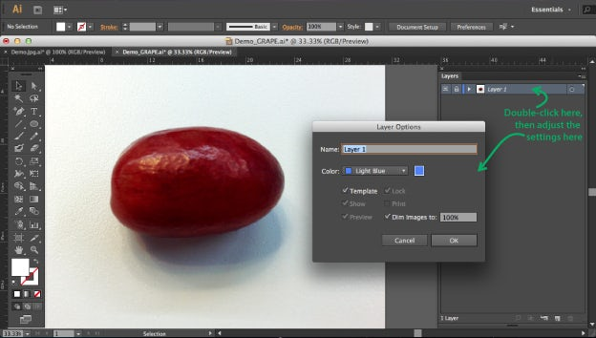

Open with your image file with Adobe Illustrator. Double click on the on your image layer in the **Layers** **Palette**. A window called **‘Layer options’** will pop up. Check **‘Template,’** check **‘Dim Images’** and set the percentage to 100%.

Doing this makes your image layer into a template for your mesh shape, which will go on top of it.

2. Trace the shape of the object

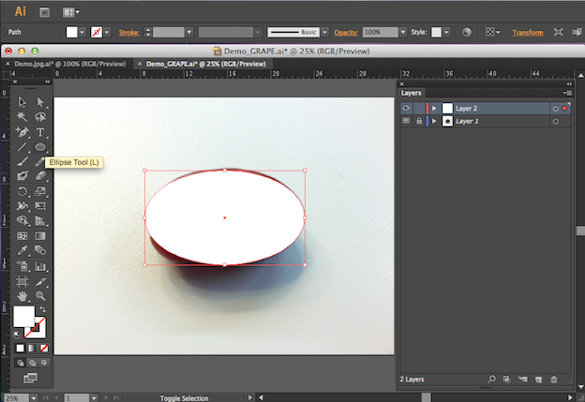

Create a new layer on top of your original image layer, and use the **Ellipse** t**ool** to create a circle. Adjust the circle so that it’s more similar to the shape of the grape.

3. View in outline mode

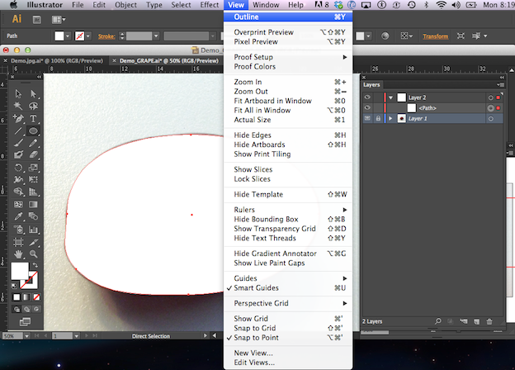

Now click **View > Outline.**This shows your mesh in **Outline mode**, so that you can still edit the mesh but can also see the photo layer underneath.

4. Open the navigator window

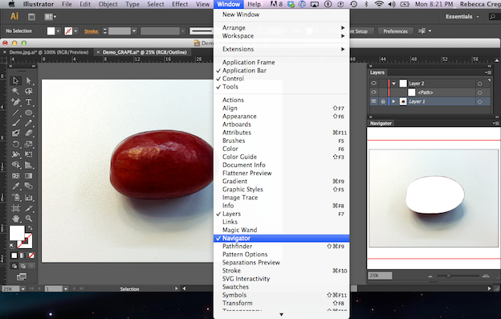

Now click **Window > Navigator** and a navigator window will pop up. This allows you to see what your mesh will look like while you’re still in Outline mode.

5. Add a mesh point

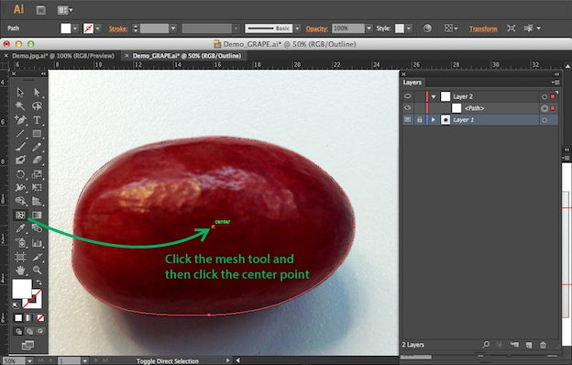

Now click on the mesh icon in the side bar, then click in the middle of the circle. You’ll see two mesh lines appear.

6. Add more mesh points where the value/color in your object changes

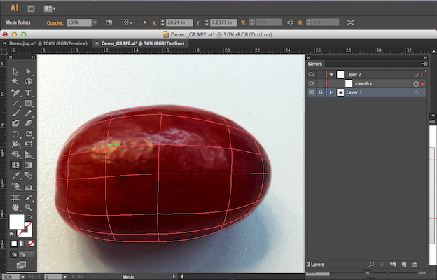

Click on different lines of the mesh to add more points, focusing on locations where the grape changes in color or value. It’s better to work with as few mesh points as possible, so I’m going to add only 5 or 6 more to this grape.

7. Use the Eyedropper tool

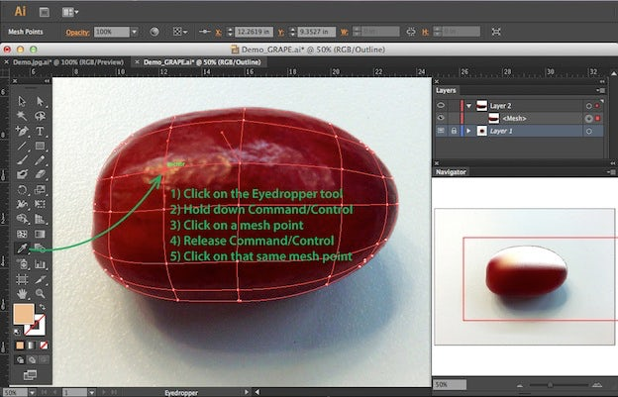

Now that we’ve got all our mesh points added, we’re going to apply colors to each of them. There’s a couple of ways to do this, but for this tutorial I’m going to use the eye-dropper tool.

Click on the eye dropper icon in the tool bar, hold down the **Command** or **Control** key and click on an intersecting mesh point inside your mesh shape. Now that your point is selected, let go of the Command or Control key and click that same mesh point with the eye dropper tool. Doing that samples colors directly from the photo and applies them into my mesh.

If you look at the Navigator palette you can see how your mesh shape is starting to look. We’re going to click **Eyedropper Tool > Command/Control > Click > Release > Click**a couple more times until all the mesh points in this grape are filled with a color swatch.

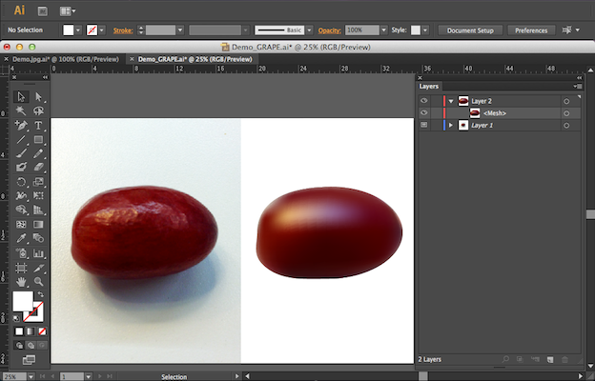

Now you have a grape. Next, click **View > Preview** to switch out of outline mode, and you’ll be able to see your grape.

It’s not super detailed and you’ll probably want to add additional [texture](https://99designs.ca/blog/tips/creating-and-using-a-texture-library/) later, but it looks more realistic than simply using a radial gradient. Pretty cool, huh?

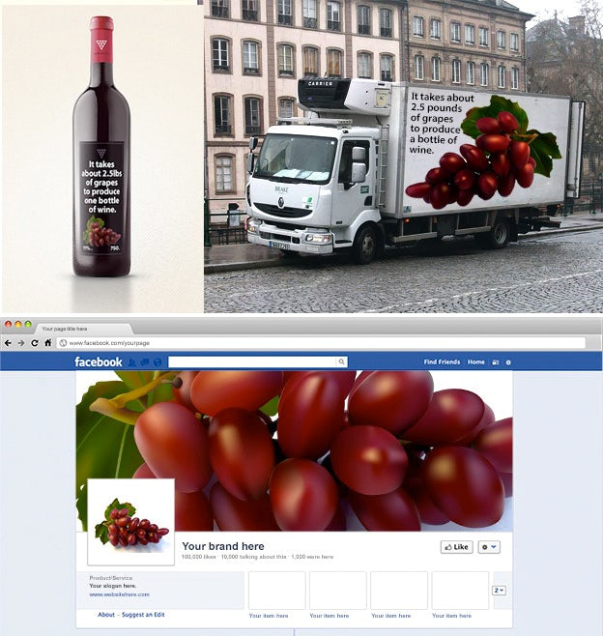

Since your illustration is a vector you’ll be able to easily size it to different mediums such as a label, a social media page, or even a truck without losing resolution. And that’s the basics of the mesh tool for you.